End to End Sentiment Analysis System Using Natural Language Processing (NLP) and Machine Learning (ML) Model Outputs

1. Overview
- This project builds a complete end‑to‑end sentiment analysis pipeline for customer product reviews from a Flipkart dataset obtained from the Kaggle website. It covers data loading, Natural Language Processing (NLP), feature engineering (Bag-of-Words and Term Frequency – Inverse Document Frequency), model training and evaluation, model persistence and two machine learning (ML) models – Naïve Bayes and Logistic Regression - to classify text into three categories: positive, negative, or neutral. The final outputs shown here correspond to: Naïve Bayes CountVectorizer, Naïve Bayes TF-IDF Vectorizer and Logistic Regression with TF-IDF Vectorizer. The Logistic Regression with TF-IDF Vectorizer is used for the Tkinter-based GUI sentiment predictions.
- Detailed code for these models can be found in the respective Jupyter notebook of model outputs for this project on the Github repository at https://github.com/henrykwong-ai-ds-ml/FlipKartSentimentAnalysis.
2. Overall Performance Metrics
Machine Learning Model Performance Comparison
Models | Class/Label | Precision | Recall | F1 Score | Overall Accuracy
Model 1:  Naïve Bayes CountVectorizer | Negative | 0.78 | 0.85 | 0.82 | 0.92
 | Neutral | 0.48 | 0.36 | 0.41
 | Positive | 0.96 | 0.96 | 0.96
Model 2:  Naïve Bayes TF-IDF Vectorizer | Negative | 0.79 | 0.82 | 0.81 | 0.92
 | Neutral | 0.82 | 0.18 | 0.30
 | Positive | 0.94 | 0.98 | 0.96
Model 3:  Logistic Regression TF-IDF Vectorizer | Negative | 0.88 | 0.90 | 0.89 | 0.94
 | Neutral | 0.72 | 0.4 | 0.51
 | Positive | 0.96 | 0.98 | 0.97

Conclusions
- Model 1 vs. Model 2: The baseline Naïve Bayes model performed identically with both text vectorization strategies (CountVectorizer vs. TF-IDF), achieving an overall accuracy of 92%.
- Model 3 (Top Performer): Upgrading to Logistic Regression yielded a notable jump in performance, increasing overall classification accuracy to 94%. More importantly, it dramatically improved precision and F1-score for the difficult Neutral class (Precision rose from 0.48 to 0.72).
3. Confusion Matrices
- Naïve Bayes Sentiment Confusion Matrix
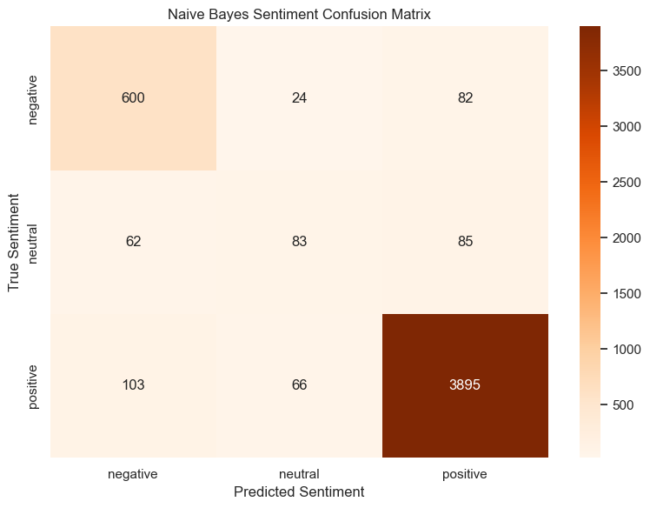

The Naïve Bayes confusion matrix reveals that while the model excels at identifying positive sentiment, it is highly conservative and inaccurate when evaluating neutral statements due to a severe data imbalance where positive reviews overpower baseline statistical probabilities. Consequently, Neutral reviews are often misclassified as Positive. The model shows a respectable accuracy for negative feedback showing its ability to pick out actual negative reviews (85% Recall) and guessing reviews of whether a negative actually turns out to be negative (78 % Precision).
- Logistic Regression Confusion Matrix
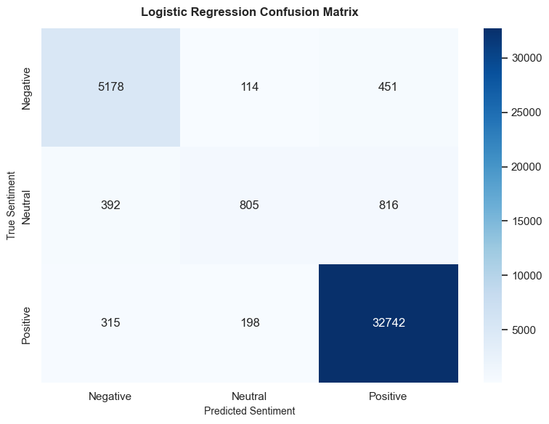

The Logistic Regression confusion matrix reveals outstanding predictive strength for the dominant Positive class with 32,742 correct classifications and highly reliable performance for the Negative class with 5,178 correct hits. However, the model encounters a clear bottleneck with Neutral sentiment, correctly identifying only 805 instances while frequently misclassifying the rest as either Positive or Negative. This demonstrates excellent overall accuracy for highly polarized customer feedback, although identifying middle-ground neutral nuances remains a challenge due to class imbalance.
4. F1 Score Comparison
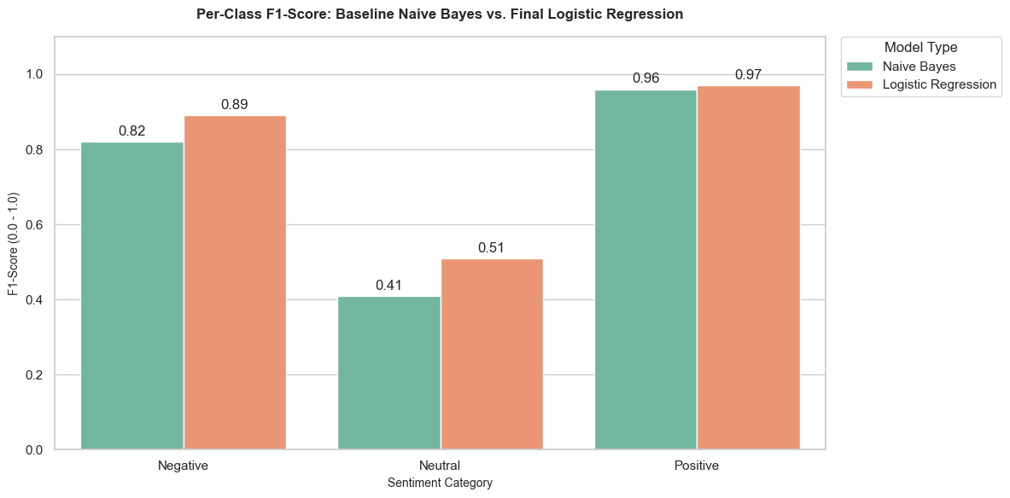
The per-class F1-score bar chart highlights that both models achieve near-perfect predictive success on the Positive class (0.96 vs. 0.97), leveraging the dataset's massive category bias. However, it visually exposes a severe performance bottleneck for Neutral sentiment in the baseline Naive Bayes model (0.41), which struggles to isolate middle-ground feedback. By changing to Logistic Regression, the chart demonstrates a successful performance breakthrough, significantly elevating the Neutral class F1-score to 0.51 and the Negative class to 0.89 through more precise tracking.

5. Example predictions and error analysis based on our top performing model: Logistic Regression
Examples of Correct Predictions
Review Text Snippet | True Label | Predicted Label
"excellent product and very fast delivery highly recommend" | Positive | Positive
"absolutely love it, works perfectly and worth every penny" | Positive | Positive
"worst experience ever stopped working after two days" | Negative | Negative
"terrible quality, completely useless and broke instantly" | Negative | Negative
"average quality for this price point not bad but not great" | Neutral | Neutral

Correctly classified reviews typically feature highly polarized, unambiguous anchor words (such as "excellent", "highly recommend", or "worst") that carry massive statistical weight in both the vectorizer and the classification models. These "easy" examples completely lack conflicting emotional phrases or subtle sarcasm, allowing the model to cleanly map the text directly to its correct sentiment profile without any contextual confusion.

Examples of Misclassifications
Review Text Snippet | True Label | Predicted Label | Why It's Confusing
"delivery took two weeks but the camera quality is absolutely amazing" | Neutral | Positive | Mixed sentiment: Praise outweighs the complaint.
"i guess it works as advertised nothing special" | Neutral | Negative | Ambiguous tone: Low enthusiasm mistaken for dislike.
"the product is okay but the customer service was a total nightmare" | Negative | Neutral | Conflicting phrases: Structural balance masks the anger.
"not as bad as people say it is" | Positive | Negative | Double negation: Negative keyword triggers incorrect weights.
"I expected a lot more from this brand given the premium price tag" | Negative | Positive | Implied expectation: Brand prestige keywords trick the model.

The model's primary errors occur along the Neutral vs. Positive and Neutral vs. Negative boundaries, where reviews contain both praise and complaints that cancel each other out mathematically. The classifier heavily struggles with shorter, ambiguous sentences and complex linguistic structures like double negatives (e.g., "not bad") or passive disappointment (e.g., "expected a lot more"), which confuse standard word-coefficient mapping. In addition, because the training data is heavily dominated by five-star ratings, the model possesses a structural bias that frequently pushes middle-ground comments or subtle complaints into the positive category if any premium brand keywords are present.
6. Summary of Model Performance
Ultimately, Logistic Regression Model 3 delivers strong predictive performance for highly polarized customer feedback, maintaining exceptional accuracy on the dominant Positive and Negative classes while breaking through the baseline limitations to better isolate Neutral sentiment.
Based on the F1-score comparison, the Logistic Regression model is highly effective at identifying Positive sentiments, achieving a near-perfect F1-score of 0.97, and shows strong performance for Negative sentiments with an F1-score of 0.89. However, the model struggles noticeably with the Neutral class, where it suffers from a low recall of 0.40, indicating it frequently misses neutral reviews. Despite this limitation in the neutral/minority class, the model generally delivers a robust F1 score.
All underlying code, data cleaning pipelines, and visualization cells used to generate these final metrics and plots are in Jupyter notebooks which can be reviewed directly in the repository workspace at the following file path or github repository: https://github.com/henrykwong-ai-ds-ml/FlipKartSentimentAnalysis.

